1. Source Code Praktikum

#include <iostream>

using namespace std;

struct circular{

int f = 0;

int r = -1;

int i,j,q[50],x,pil,n;

char ulang;

} c;

void menu() // menampilkan menu

{

cout<<"Pilihan "<<endl;

cout<<"1. Enqueue "<<endl;

cout<<"2. Dequeue "<<endl;

cout<<"3. View "<<endl;

}

void view() // untuk melihat data

{

cout<<"Data : ";

for(c.i=c.f;c.i<=c.r;c.i++){

cout<<c.q[c.i]<<" ";

}

cout<<"\n";

}

void dequeue() // proses dequeue

{

c.x = c.q[c.f];

c.f = c.f+1%c.n;

}

int enqueue(int x) // proses enqueue

{

c.r = c.r+1%c.n;

c.q[c.r] = c.x;

}

bool isFull() // mengecek apakah penuh

{

if(c.r-c.f == c.n-1){

return true;

}

return false;

}

bool isEmpty() // mengecek apakah kosong

{

if(c.f == c.r+1){

return true;

}

return false;

}

int main()

{

cout<<"Batas Data ";

cin>>c.n;

cout<<endl;

do{

cout<<"================"<<endl;

cout<<"================"<<endl;

menu();

cout<<"masukkan pilihan ";

cin>>c.pil;

cout<<endl;

if( c.pil == 1 ){

if(!isFull()){

cout<<"Masukkan data ";

cin>>c.x;

enqueue(c.x);

cout<<"\n Data yang anda masukkan adalah "<<c.q[c.r]<<endl;

}

else{

cout<<"Data Penuh"<<endl;

}

}

else if ( c.pil == 2 ){

if(!isEmpty()){

dequeue();

cout<<"Data terhapus "<<c.x<<endl;

}

else{

cout<<"Data Kosong"<<endl;

}

}

else{

view();

}

cout<<endl;

cout<<"apakah ingin mengulang ";

cin>>c.ulang;

}while( c.ulang == 'y' );

}

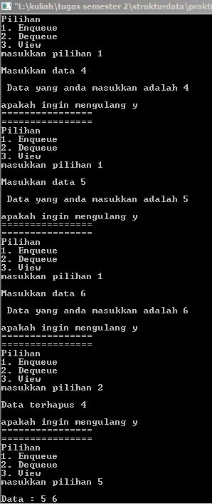

1. Source Code Tugas Tambahan

* File praktikum.h

#ifndef PRAKTIKUM_H_INCLUDED

#define PRAKTIKUM_H_INCLUDED

#include <iostream>

struct catalog_buku{

char nama_barang[100],kota_penjual[100];

int harga,stok;

};

struct jasa_pengantar{

char nama_jasa[100];

int tarif;

};

struct data_pembayaran{

char nama_bank[100];

int no_rekening,jml_transfer;

};

struct data_pembelian{

catalog_buku cbuku;

jasa_pengantar jp;

int jml_pembelian,total_pembelian;

};

struct data_pembeli{

data_pembelian dpembelian;

data_pembayaran dpembayaran;

char nama[100],alamat[100];

};

* File main.cpp